**LEBANESE AMERICAN UNIVERSITY**

**USAID – HIGHER EDUCATION SCHOLARSHIP PROGRAM**

**HES - Volunteering Program Verification Form**

This form is to be used to document volunteering hours. If a student volunteers for multiple organizations, a separate form must be used for each organization. **This form must be turned in by the 28th of each month, the latest.**

I certify that the scholar Raghad Ziad Rashed completed a total of 5 hours of service at InnovaThrive.

The hours were completed hours as per the below:

Hours # 0 (date) _2/12 – 6/12_ (initials of supervisor) __A.K.___

Hours # 0 (date) _9/12 – 13/12_ (initials of supervisor) __A.K.___

Hours # 0 date) _16/12 – 20/12 (initials of supervisor) __A.K.___

Hours # 5 date) _23/12 - 27/12 (initials of supervisor) __A.K.___

Brief description of the activities the scholar performed or participated in:

I did a research task on Technology including AI in Advancing Renewable Energy Storage Solutions  
Definition: Using AI to optimize the efficiency and reliability of energy storage technologies.  
Technologies:  
Machine learning models for battery performance predictions.  
AI-driven energy storage management systems.  
Applications:  
Extending battery life in solar and wind energy systems.  
Dynamic allocation of stored energy based on real-time demand.  
Statistics: AI-optimized storage systems reduce energy losses by up to 30%.  
Advantages:  
Increasing the viability of renewable energy sources.  
Lowering operational costs for energy providers.  
Disadvantages:  
High costs of implementing AI in storage technologies.  
Challenges:  
Ensuring compatibility with various energy grids.  
Future Research:  
AI for innovating hydrogen-based energy storage.  
Expanding storage systems for decentralized energy markets.

Written feedback about the scholar’s performance:

Raghad’s research on AI in renewable energy storage highlighted its role in optimizing efficiency and reducing energy losses. Her exploration of AI-driven systems for dynamic energy allocation was insightful, showing great potential for future energy solutions.

Please rate the overall performance of the scholar at your organization:

|  |  |  |  |
| --- | --- | --- | --- |
|  | Mastery (5) | Proficient (3) | Emerging (1) |
| **Problem solver** | X |  |  |
| **Engaged & Committed** | X |  |  |
| **Open-minded & multicultural** | X |  |  |

Signature

& stamp

__________________________

_

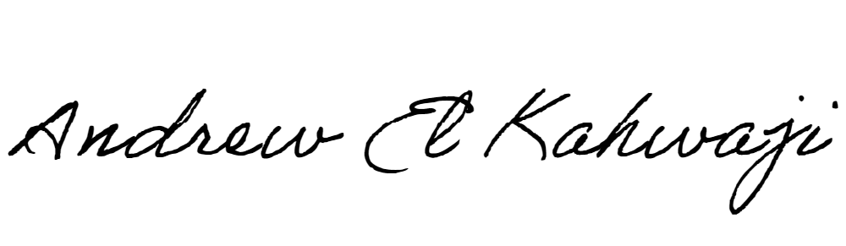

Printed Name _Andrew El Kahwaji_

Date __26/12/2024___

Email __andrew.lifesculptor.coo@gmail.com __

Phone __+961 71 914 378__